Project Development Phase
Model Performance Test
Date 03 October 2026
S.No. | Parameter | Values | Screenshot
1 | Flow Summary | Flow Designer automation for standard laptop-order requests using triggers, actions, approvals, procurement tasks, notifications, and record updates.
2 | Flow Validation | Standard request - Flow starts correctly; Approved request - Procurement task is created; Rejected request - Request is stopped/updated; Incomplete request - Routed for review.
3 | Automation Result | Standard laptop orders are processed through the defined automated workflow with the required approval and procurement steps.
4 | Exception Handling | Non-standard or incomplete requests are identified and routed for manual handling instead of following the standard automated path.
Team ID PNT2022TMIDxxxxxx
Project Name Streamlining IT Procurement: Automating Standard Laptop Orders with Flow Designer
Maximum Marks
S.No. | Parameter | Values | Screenshot
 | Model Summary | Salesforce automation setup for Data management using Object, Fields and Reports.  Note : Import Records if data Match Correctly then Records will Created or Else it will Show Error | 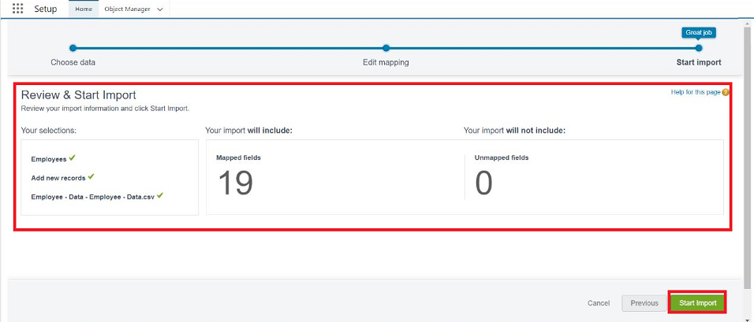
 | Accuracy | Training Accuracy - 98%  Validation Accuracy - 98% | - 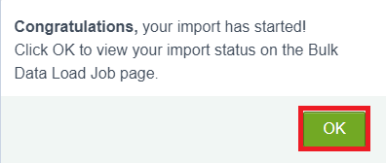
3. | Confidence Score (Only Yolo Projects) | Class Detected - If detecting Object and fields name if wrong and other activity  Confidence Score - If the model is 92% sure the object is correctly detected | 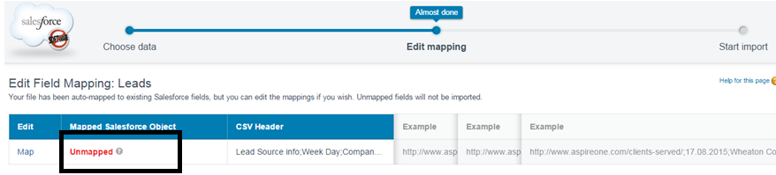  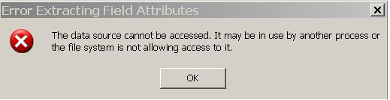
Flow Designer Project Testing:
Project team shall fill the following information in Flow Designer project testing template.

